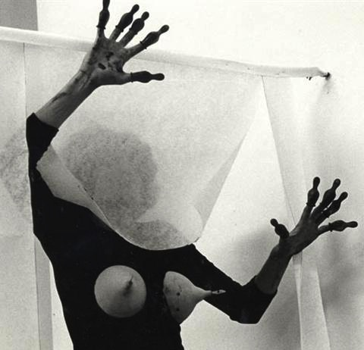
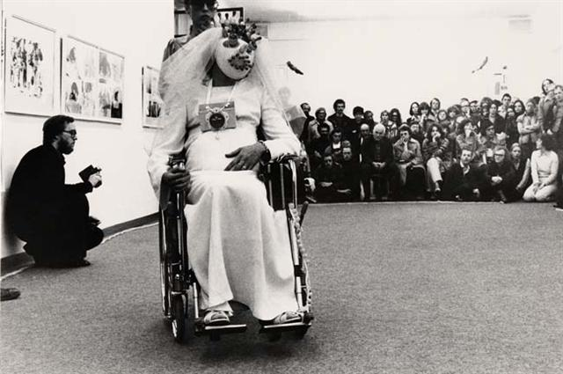
Renate Bertlmann b. 1943
Lives and works in Vienna, Austria

Detailed CV to 1990

Thumbnails from performances as underlined in CV, clockwise

1964-70
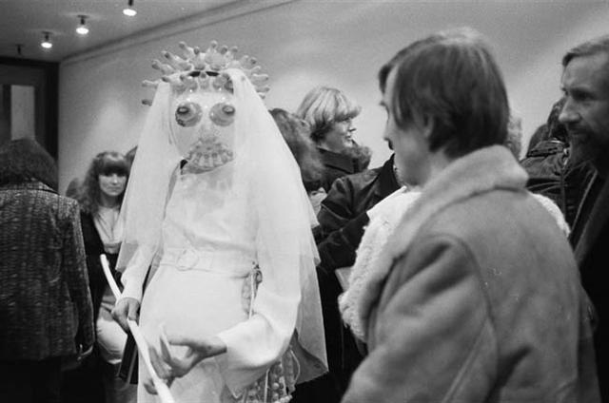
Studied at the Academy of Fine Arts, Wein; worked as a lecturer at the Academy 1970-82

1976 Magna feminismus, Galerie St. Stephan, Wìen
(curated by Valie Export)
1977 Künstlerinnen International, Schloss Charlottenburg, Berlin
Defloration in 14 stages, Museo Comunale d'Arte Moderna,
Bologna
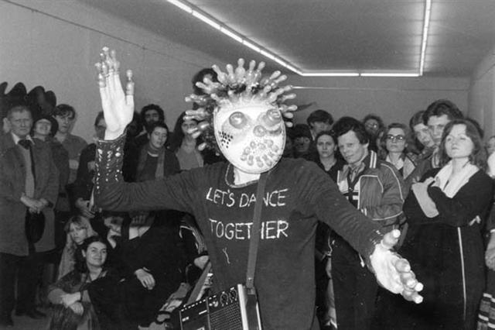
1978 Festival einer anderen Avantgarde, Brucknerhaus, Linz
Pregnant Bride in the Wheelchair, Österreichischer Kunstverein, Wein
Pregnant Bride with the Collection-bag, Städtische Kunsthalle, Düsseldorf
1979 Let’s Dance Together, Galerie Modern Art, Wien, Stichting de appel, Amsterdam
1980 Sling Shot Action, Franklin Furnace New York, Nordstadt-Galerie-Kollektiv, Wuppertal
Received Z-Promotional award
1982 Stimmen der Sehnsucht, Galerie Apropos, Luzern
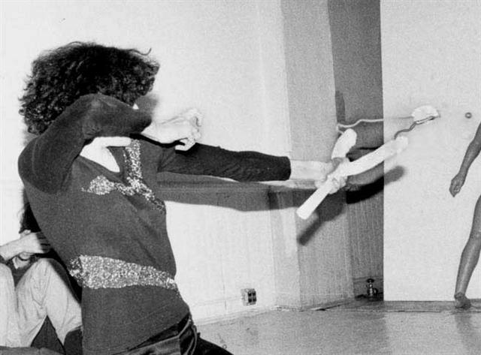
1985 Kunst mit Eigen-Sinn, Museum Moderner Kunst, Wien
1986 Bestehend-lebend-gegenwärtig, Museum Villa Stuck, München
1988 Received Theodor Körner Preis, and Great Award of the City of Vienna 2007

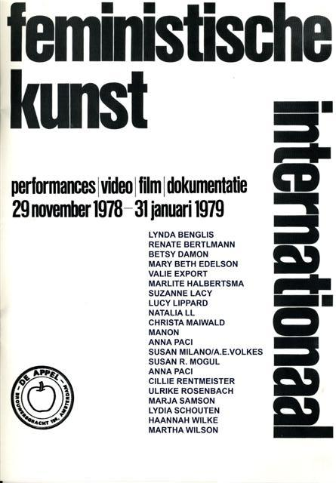
Catalogue published by De Appel/The Hague, 1979

Major exhibitions since 1990

1991 Außerhalb von Mittendrin, NGBK, Berlin
1993 Schneegestöber - Flitter(s)türme, Kunsthalle Exnergasse, Wien
2002 Werkschau VII, Arbeiten von 1976 – 2002, Fotogalerie Wien
2003 Künstlerinnen – Positionen 1945 bis heute, Kunsthalle Krems
2008 MATRIX, Geschlechter/ Verhältnisse/Revisionen, Museum on
Demand, Wein
2009 VIDEORAMA — Kunstclips aus Österreich, Kunsthalle Wien
2009 rebelle. art and feminism 1969 - 2009, Museum voor Moderne
Kunst Arnhem
2010 Donna: Avanguardia Femminista Negli Anni '70 dalla
Sammlung Verbund
Wein, Galleria Nazionale d'Arte Moderna, Roma
2013 Mujer/Woman: The Feminist Avant-Garde from the 1970s.
Works from the Sammlung Verbund, Circulo de Bellas Artes,
Madrid
2014 Emotional Resources, Northern Gallery for Contemorary Art,
Sunderland

Zärtliche Pantomime, staged photography, 1976

Renate Bertlmann, based in Vienna, was a pioneer of the European Feminist avant-garde of the 70s. In her determination to explore the female psyche, she has produced work in a range of media and forms; objects, photography, performances, the moving image and a large body of work on paper.
Bertlmann’s work builds on the development of the female-image in Western society. She was one of the few women artists interested in playing with both the roles of the ‘man’ and the ‘woman’. She is well known for her photographs featuring inflated condoms and fetish objects, sexual toys and erotic iconography.

The striking images Bertlmann has created are ones of contrast and surprise – at once feminine and masculine, tender and aggressive, funny and serious, sexy and repulsive, wild yet sometimes familiar.

Although widely known, she has had few exhibitions and her work remains rarely seen. A major monograph is planned for 2014 at which point a full reassessment of the artist is to be expected.

