Taking Matters Into Our Own Hands: Exhibition List

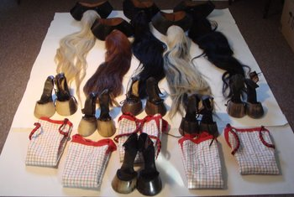 | Rose ENGLISH  Quadrille, 1975  1 dvd and mixed media: performance costumes including 5 real and 1 synthetic horse tails, 6 cloth tunics, and 6 pairs of horse hoof high heels, 20 black & white vintage photographs of performance, Southampton Show Leaflet, 2 additional colour c-type photographs and 1 b&w c-type photograph  Varying dimensions  (ROE002)
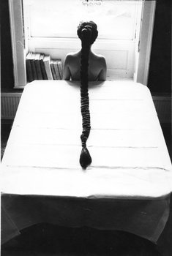 | Rose ENGLISH  Harriet and Plait, 1976  Set of 6 black and white vintage photographs  15.9 x 24.1 cm each  Unique  (ROE009)
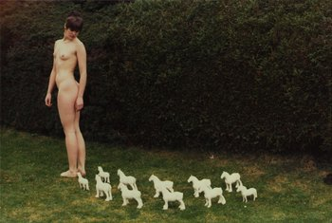 | Rose ENGLISH  Rose and Porcelain Horses, 1975/2012  c-type photograph  76.2 x 50.8 cm (sheet size)  edition of 6 plus 4 AP's  (ROE008)
Rose ENGLISH
Rose on Horseback with Tail, 1974/2012
c-type photograph
76.2 x 50.8 cm (sheet size)
edition of 6 plus 4 AP's
(ROE010)

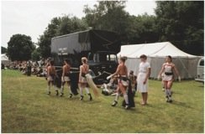 | Rose ENGLISH  Quadrille, 1975/2012  c-type photograph  76.2 x 50.8 cm (sheet size)  edition of 6 plus 4 AP’s
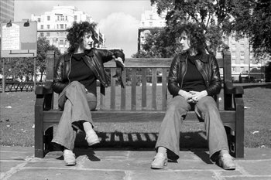 | Rose FINN-KELCEY  Set of five prints: Here is a Gale Warning, Divided Self, Variable Light to Moderate, Fog, Power for the People, c.1972 - 2011  Accompanied by a signed and numbered label  Set of 5 prints  46.6 x 70 cm each  Edition of 10 plus 2 AP’s  (RFK006)
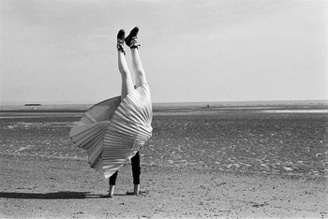 | Rose FINN-KELCEY  The Restless Image – a discrepancy between the felt position and the seen position, 1975 – 2011  Selenium-toned bromide print  Accompanied by a signed and numbered label  89 x 112 cm (sheet size)  Edition of 5 + 2 AP’s  (RFK007)
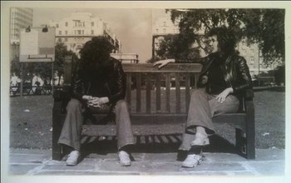 | Rose FINN-KELCEY  Study for Divided Self I, II, III, 1974  3 vintage photographs, each in two parts  40.5 x 66.6 cm each  (RFK008)
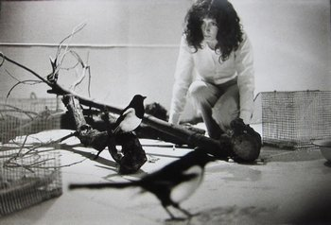 | Rose FINN-KELCEY  One for Sorrow, Two for Joy, 1976  Collection of approximately 30 vintage photographs of the artist's first performance  Sizes from 14 x 20 cm to 30 x 40 cm  (RFK017)
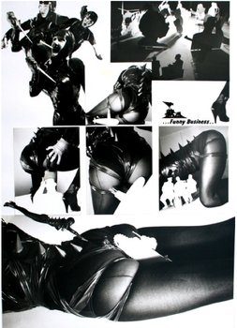 | Rose FINN-KELCEY  Funny Business, 1984  collaged photographs on board  43 x 30 cm  (RFK018)
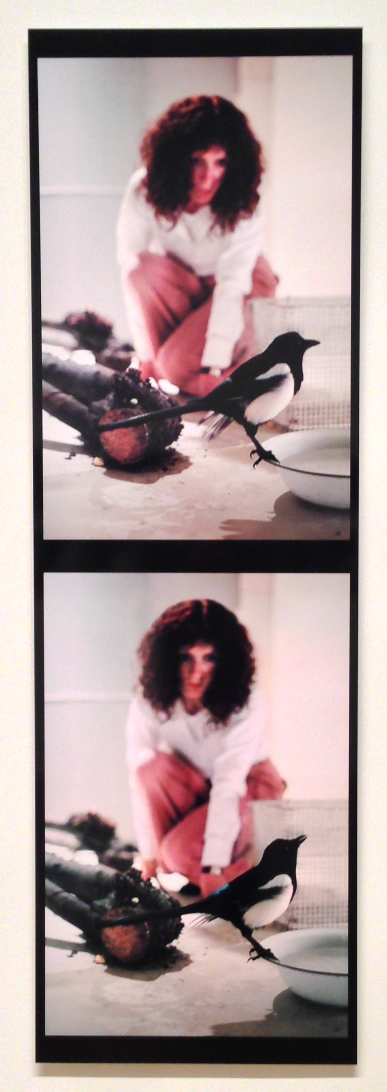 | Rose FINN-KELCEY  One for Sorrow, Two for Joy, 1976/2012  2 photographs mounted on aluminium  167.5 x 53 cm  Edition of 2 plus 1 AP  (RFK019)
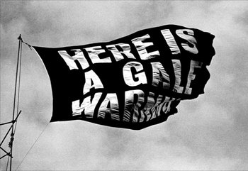 | Rose FINN-KELCEY  Here is a Gale Warning, 1971 / 2012  Black and white photograph mounted on aluminium  101.6 x 152.4 cm  Edition of 1 plus 1 AP  (RFK020)
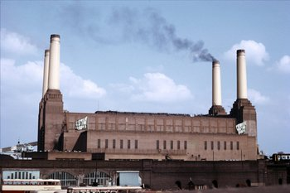 | Rose FINN-KELCEY  Power for the People, 1972/2012  Colour photograph mounted on aluminium  101.6 x 152.4 cm  Edition of 1 plus 1 AP  (RFK021)
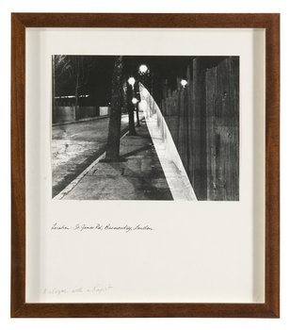 | Alexis HUNTER  Dialogue with a Rapist, 1978  10 unique black and white photographs with handwritten script in Indian Ink  41 x 36.2 cm  (AHU017)
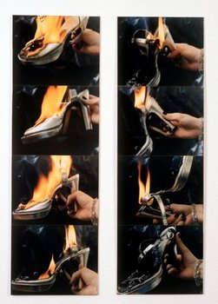 | Alexis HUNTER  Approach to Fear XIII: Pain - Destruction of Cause, 1977  2 panels, each with 4 colour photographs  103.3 x 43 cm each panel  (AHU018)
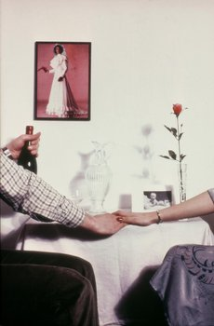 | Alexis HUNTER  Domestic Warfare, 1979/2012  Twenty c-type photographs  20.3 x 25.4 cm  Edition of 3 plus 1 AP  (AHU049)
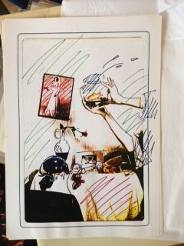 | Alexis HUNTER  Domestic Warfare, 1979  Set of 9 hand-coloured xeroxes  29.5 x 21 cm each  (AHU050)
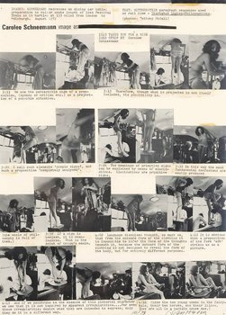 | Carolee SCHNEEMANN  Image as #I: Isis Skating, 1973  Photos and type on board  42.5 cm x 30 cm  (CSC001)
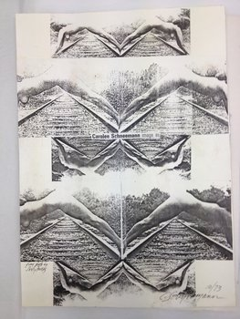 | Carolee SCHNEEMANN  Image as #II, 1973  Xerox collage on board  42.5 x 30.2 cm  (CSC004)
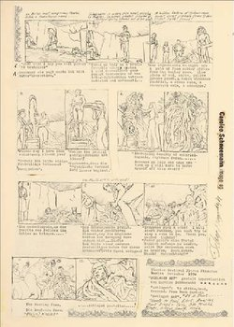 | Carolee SCHNEEMANN  Image as #III, 1973  Collage on board  42 x 30 cm  (CSC003)
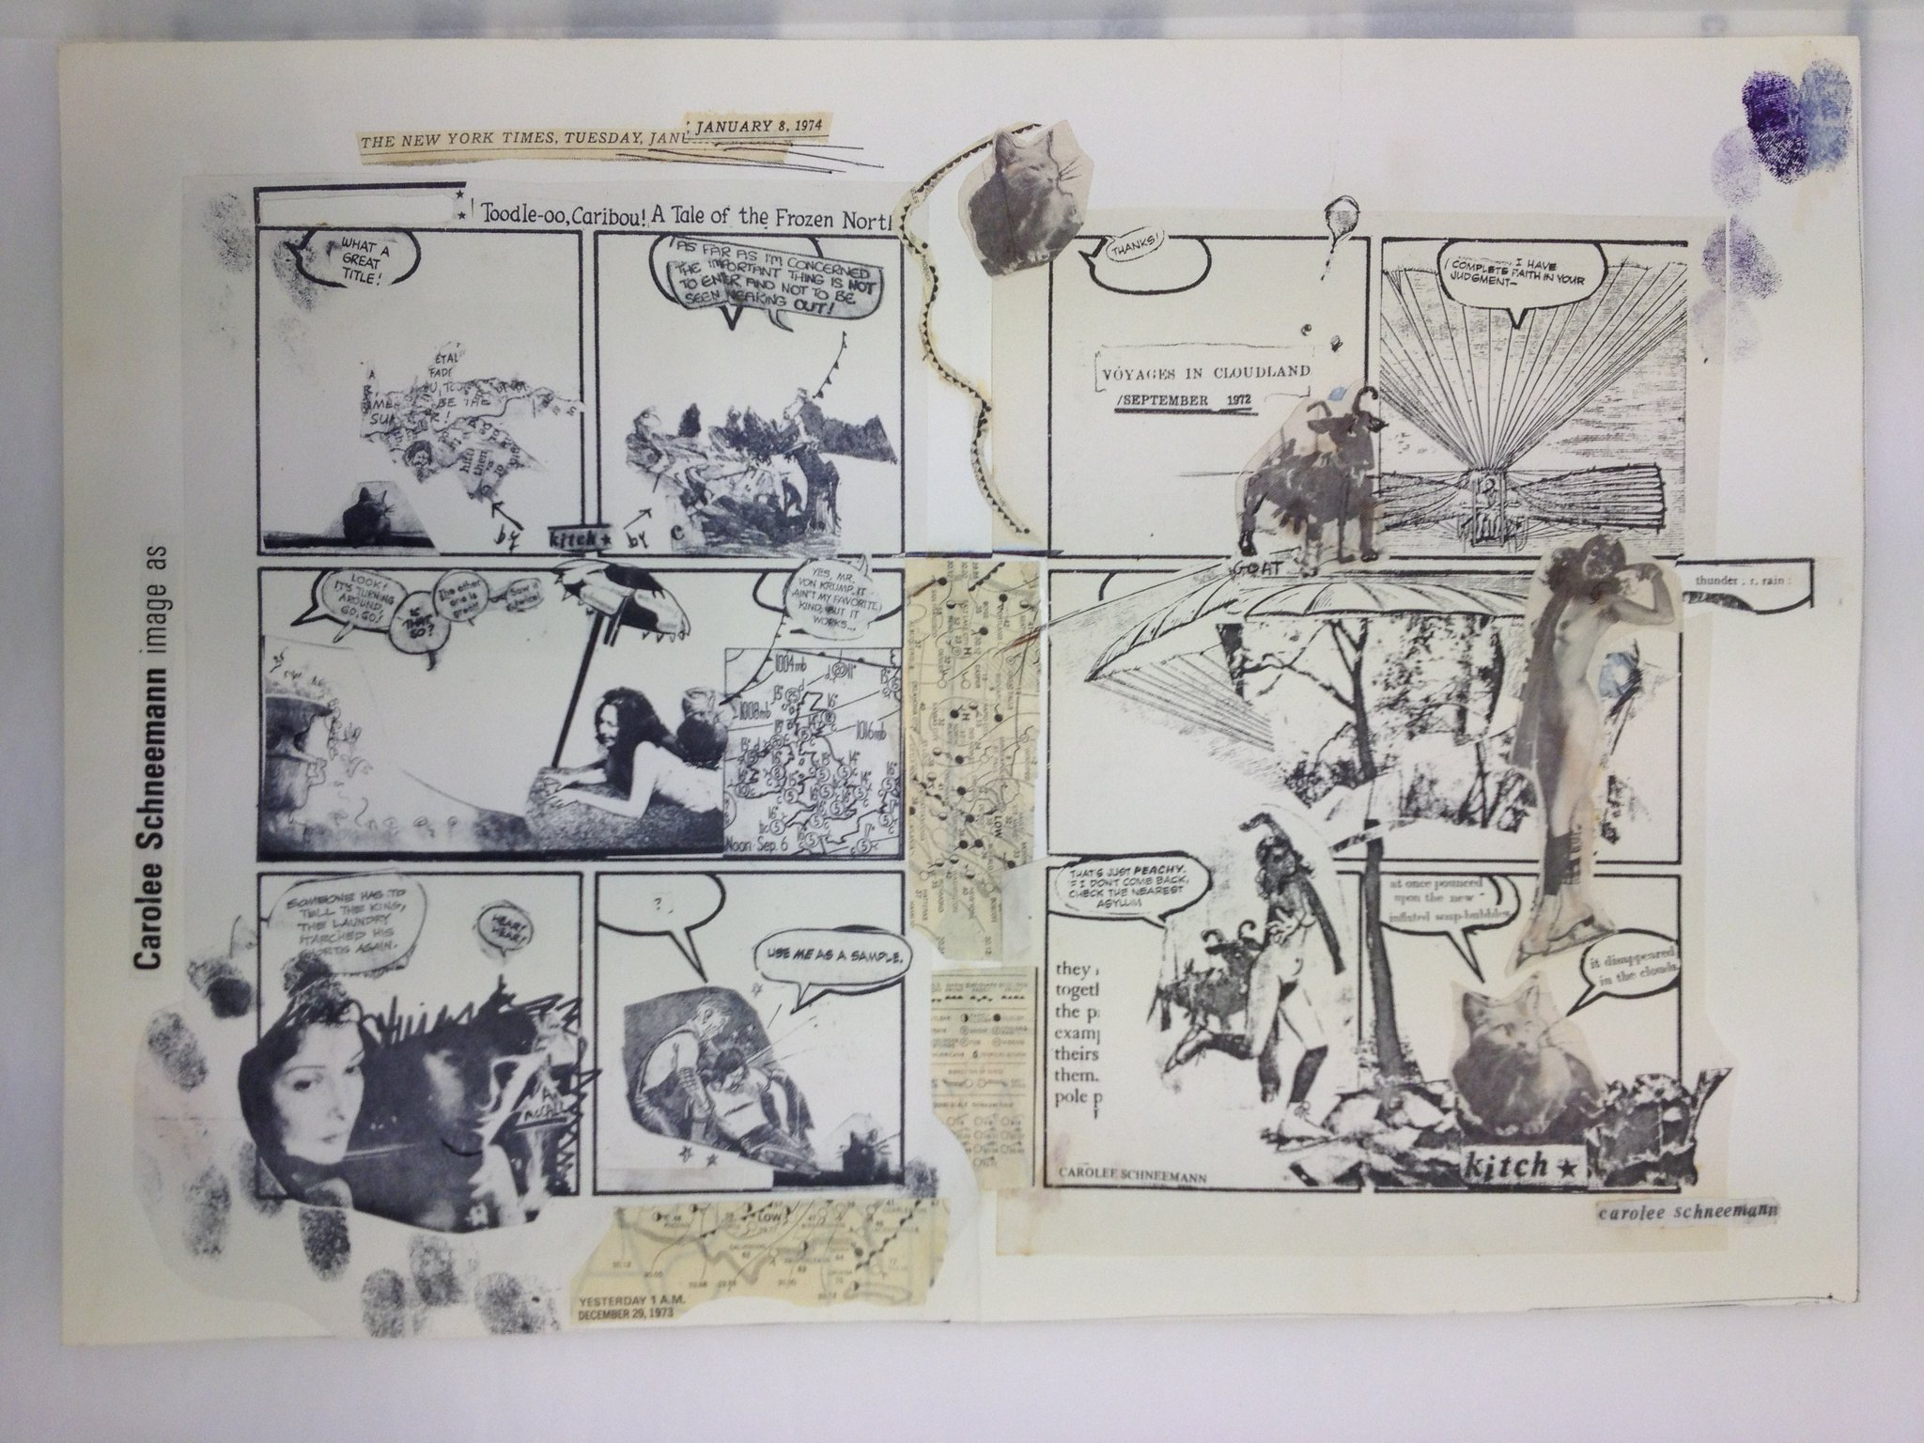 | Carolee SCHNEEMANN  Image As #4, 1974  Collage and ink on paper  29.5 x 42 cm  (CSC016)
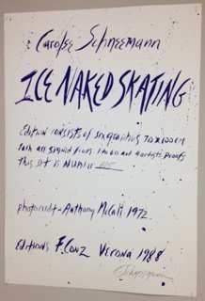 | Carolee SCHNEEMANN  Ice Naked Skating, 1972/1988  Set of 6 photo-lithographs  100 x 70 cm each  Edition of 60  (CSC005)
Carolee SCHNEEMANN
Ices Skating, 1972
Set of six vintage black and white photographs with ink
20.3 x 25.4 cm each
(CSC008)

Carolee SCHNEEMANN
Boa Constrictor, 1975
Vintage black and white photograph
20.3 x 25.4 cm
(CSC009)

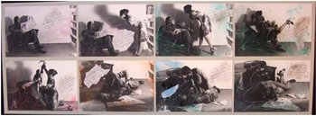 | Carolee SCHNEEMANN  Aggression for Couples, 1972  8 hand-coloured photographs mounted with collage  43.8 x 113.7 cm overall  (CSC010)
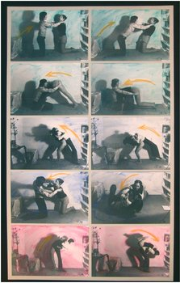 | Carolee SCHNEEMANN  Exercise for Couples, 1972  10 hand-coloured photographs mounted with collage  99.1 x 58.4 cm overall  (CSC011)
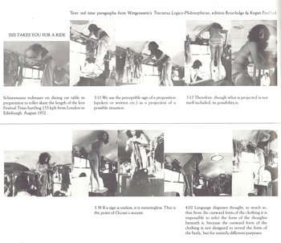 | Carolee SCHNEEMANN  Isis Skating, 1972/2005  20 gelatin silver photographs with text  27.9 x 35.6 cm each  Edition of 2  (CSC014)
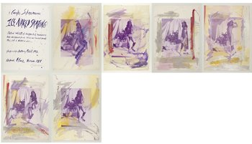 | Carolee SCHNEEMANN  Ices Skating, 1972/1988  6 hand-coloured photo-lithographs  70 x 100 cm each  (CSC015)
VAT at 20% where applicable

